Stan,

I will speak to my distributor today, and will get back to you on some very specific models available.

These are for a general look see. - only about 1/10th of what he carries

Dorian

RSR

GALCO MIAMI CLASSIC P220/229 RH TAN

RSR Item #: GALMC248

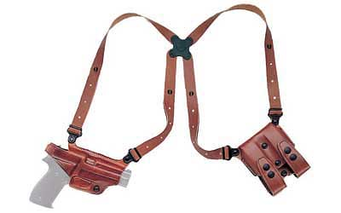

Product Specifications
- UPC Code: 0601299069671
- Manufacturer: Galco
- Model: Miami Classic
- Type: Shoulder Holster
- Hand: Right Hand
- Finish/Color: Tan
- Barrel Length: 4.5"
- Fit: Sig220, 226
- Manufacturer Part #: MC248
$104.99
MSRP: 179.95

BULLDOG PRO DLX SHLDR LG AUTO

RSR Item #: BDWSHD8

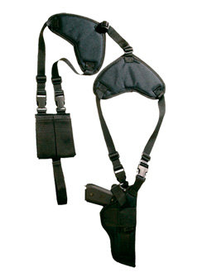
my cost without shipping $23.31

Product Specifications
- UPC Code: 0875591000803
- Manufacturer: Bulldog Cases
- Model: Horizontal Shoulder
- Model: Deluxe
- Type: Shoulder Holster
- Hand: Ambidextrous
- Finish/Color: Black
- Fit: Large Auto
- Accessories: Ammo Pouch
- Manufacturer Part #: WSHD 8

BH SERPA COMBO KT LG BER RH CT

RSR Item #: BH40SC03CT-R

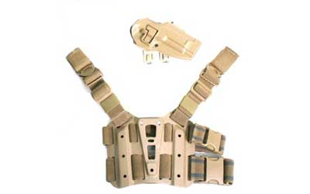

Product Specifications
- UPC Code: 0648018048005
- Size: Large
- Manufacturer: BlackHawk
- Model: S.T.R.I.K.E.
- Model: SERPA
- Type: SERPA Holster Kit
- Hand: Right Hand
- Finish/Color: Coyote Tan
- Fit: Ber 92/96 (not Elite/Brig)
- Frame/Material: Carbon Fiber
- Accessories: Holster/Belt and Shoulder and Thigh Mount
- Manufacturer Part #: 40SC03CT-R
$107.99
MSRP: 179.99

BH VERT SHLDR HLSTR SCPD SZ 3 RH BLK

RSR Item #: BH40SV03BK-R

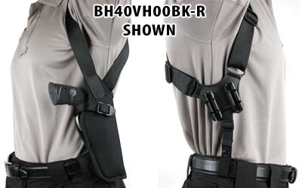

SAMPLE - NOT FOR YOUR GUN, WILL HAVE TO INQUIRE

Product Specifications
- UPC Code: 0648018100468
- Manufacturer: BlackHawk
- Model: Scoped
- Model: Vertical Shoulder
- Type: Shoulder Holster
- Hand: Right Hand
- Finish/Color: Black
- Barrel Length: 6.5"
- Fit: Scoped 5 - 6½" DA or 4 5/8 -5 ¼" SA Revolver
- Frame/Material: Nylon
- Manufacturer Part #: 40SV03BK-R

$31.19
MSRP: 51.99

BH SERPA SHLDR HRNS LG BLK

RSR Item #: BH41SH01BK

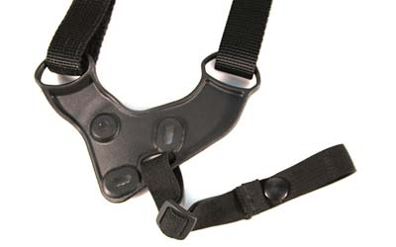

Product Specifications
- UPC Code: 0648018024283
- Size: Large
- Manufacturer: BlackHawk
- Model: SERPA
- Type: Harness
- Finish/Color: Black
- Manufacturer Part #: 41SH01BK
$34.79
MSRP: 57.99

