Item # 1-738031RSP
MSRP: $336.00
Number Available: 99
Video: (No Video)
New Search
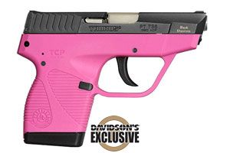

BRAND: | Taurus | # OF MAGS: | 2
MODEL: | 738 TCP | SAFETY:
TYPE: | Semi-Automatic Pistol | SIGHTS: | Low Profile Fixed
CALIBER: | 380 | BARREL LENGTH: | 2.84"
FINISH: | Blue | OVERALL LENGTH: | 5.19"
ACTION: | Double Action Only | WEIGHT: | 10.2 oz
STOCK: | Raspberry Grips | PACKAGING:
CAPACITY: | 6+1 | FEATURES: | Davidson's Exclusive, Loaded Chamber Indicator
CHOKES: |  | FEATURES: | Internal Lock
CHAMBER: |  | BUTT PLATE:
MUZZLE: |  | RECEIVER: | Blue
RESTRICTIONS

