M-4 Stock Adapter
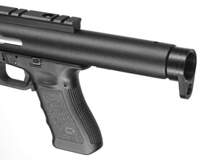 | This adapter attaches to the rear of the CCU housing. Many customers already own an M4 stock and they can mount this directly to the CCU. The adapter  accepts both military and commercial stocks.  M4A $34.95

