PM138 - Flip Up Gas Block Front Sight‏
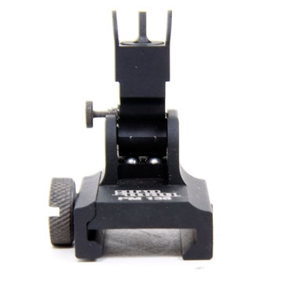
123

PM209 - Flip Up Rail Mount Front Sight‏
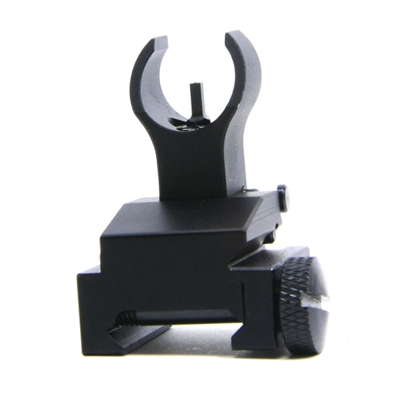

PM209 - Flip Up Rail Mount Front Sight‏
123
PM138 - Flip Up Gas Block Front Sight‏
123

