PM209 - Flip Up Rail Mount Front Sight‏
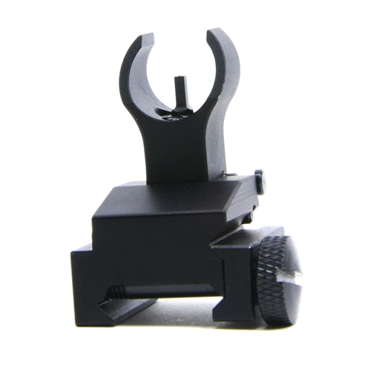

PM136 - AR-15 / M16 Flip Up Rear Single Plane Dual Aperture Sight
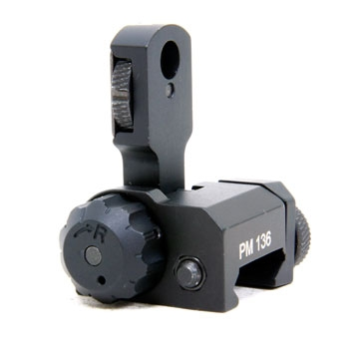
123
PM131 - Picatinny Rail Quick Disconnect Sling Swivel
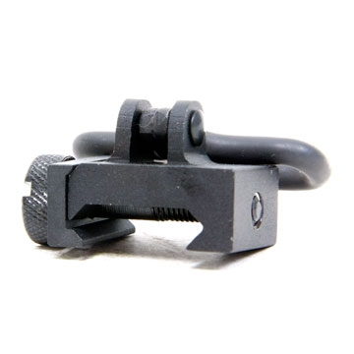
1234
PM131 - Picatinny Rail Quick Disconnect Sling Swivel
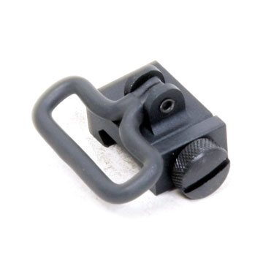
1234
k Disconnect Sling Swivel
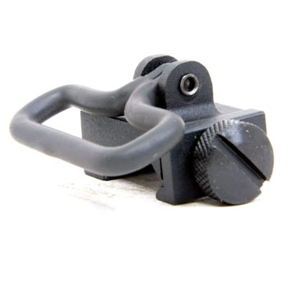
1234
PM138 - Flip Up Gas Block Front Sight‏
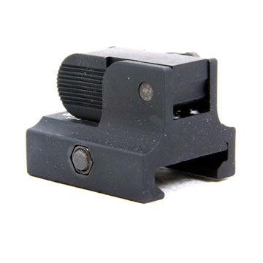
123

