PAR-A3 - Para-Ordnance P14-45* .45acp (20)Rd Blue Steel Magazine
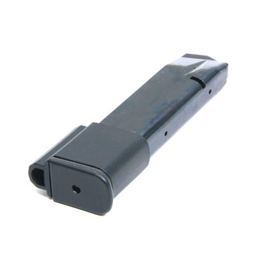
12345

PAR-A3 - Para-Ordnance P14-45* .45acp (20)Rd Blue Steel Magazine
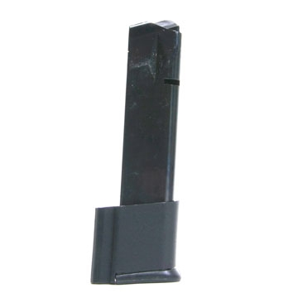
12345

PAR-A3 - Para-Ordnance P14-45* .45acp (20)Rd Blue Steel Magazine
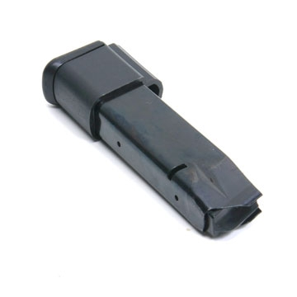
12345
PAR-A3 - Para-Ordnance P14-45* .45acp (20)Rd Blue Steel Magazine
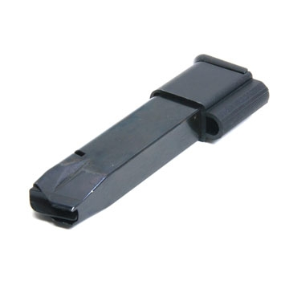

12345

PAR-A1 - Para-Ordnance P14-45 .45acp (14)Rd Blue Steel Magazine

1234

PAR-A1 - Para-Ordnance P14-45 .45acp (14)Rd Blue Steel Magazine

1234

PAR-A1 - Para-Ordnance P14-45 .45acp (14)Rd Blue Steel Magazine
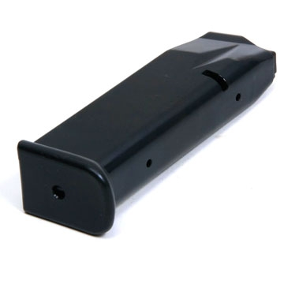
1234

PAR-A1 - Para-Ordnance P14-45 .45acp (14)Rd Blue Steel Magazine
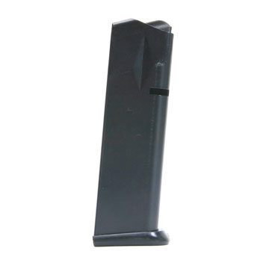
1234

