Tan Desert Mil Spec Boot
Item Code: 4156
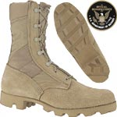  Click image to view larger size
  Our Price: $ 109.95
  Topline: Mil-spec 9" tan desert Cordura® and leather desert combat boots with Coolmax lining and padded leather collar. Nylon-coated brass speedlace system.
  • Height - 9"
  • Sole Pattern - Panama
  • Tan Desert Cordura® and Suede
  • Padded Collar
  • Outsole - Mil Spec Vulcanized Rubber
  • Midsole Heat Barrier
  • Removable Innersole - Cushioned Polyurethane
  • Coolmax® Lining
  • Nylon Coated Brass Speedhook/Eyelet Lacing System
 | 