Black Jungle Boot

  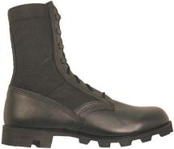
    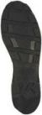
    Vulcanized DMS
    (Direct Molded Sole) construction is designed for maximum bond and durability. The government specification Panama sole features light-weight, abrasion resistant, nitrile rubber with a self-cleaning high traction tread design.
    Order size based on Issue Boot size.
  $69.95
  Top of Form
  Quantity: |  |  | Size:

  Features
  BHWCDP

- Direct Molded Sole Construction (DMS)
- Panama design high traction mud-shedding rubber sole.
- Silicone-treated upper leather and special thread for maximum resistance to water penetration.
- Speed lacing.
- No steel plate in the insole for increased comfort.
- Contour cushion insert for added comfort.

DMSconstruction

