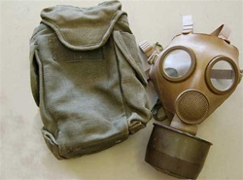

French Military ANP M51 Gas Mask Respirator

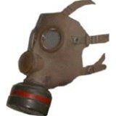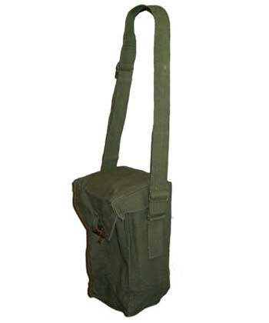

French/Belgium Gas Mask with Standard NATO Filter

Belgian Engineer Gas Mask Carrier

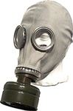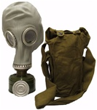

Original Soviet GP-5 Civilian issue Gas Mask kit.

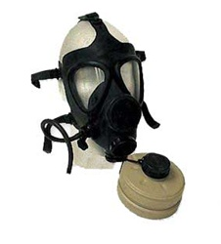

IDF M-15 Gas Mask

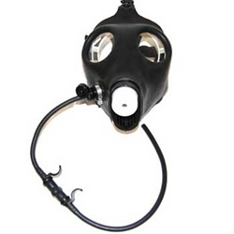

IDF Civilian Gas Mask

