http://camopedia.org/index.php?title=USA

USA
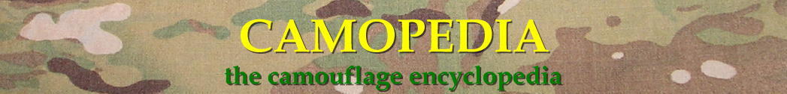

Contents
- 1 United States of America
- 2 USA Camouflage Patterns
- 3 Other Camouflage Patterns Worn by US Military Personnel
- 4 Experimental Camouflage patterns
- 5 Comparison Photos
- 6 Additional Resources
- 7 Notes

United States of America
The development of camouflage patterns specifically for military application by American forces can be traced to the First World War. Like her British and French allies, military engineers experimented with a number of designs for hiding reconnaissance personnel and snipers employed along the frontiers. One design, based on the British-designed Symien sniper suit, consisted of loose strips of multi-colored cloth, twine or burlap attached to a loose-fitting hooded jacket & trousers, designed to appear as foliage from a distance. Another uniform designed by an Army Engineer unit at the American University in Washington, DC consisted of jacket, trousers and hood painted with wide dark stripes on a lighter-colored fabric, and was intended to provide concealment specifically while hiding in trees. Manufacture and distribution of such suits, however, was minimal and although there is evidence to suggest speculation and experimentation regarding military camouflage clothing did continue in America after 1918, it was not given serious consideration until the Second World War.

USA Camouflage Patterns
- The first widespread use of camouflage by American military forces began in 1942. Prior to this point, the US Army Corps of Engineers had been applying themselves to developing camouflage for military applications as early as 1940. Nevertheless, the process of its introduction into the US supply system was rushed, brought about by an urgent request General D. MacArthur in July of 1942 for production of 150,000 jungle camouflage uniforms for use in the Pacific Theater. The pattern chosen was actually designed by civilian Norvell Gillespie (horticulturist and garden editor of Sunset, Better House and Gardens, and the San Francisco Chronicle). The green dapple or spot design, reversing to a tan/brown variation, began distribution to US military forces beginning in August of that year. Nicknamed “frogskin” by many GIs, the pattern consists of a five color green dominant “jungle” camouflage pattern printed on one side, with a three color brown dominant “beach” pattern printed on the opposite side. Produced in a variety of uniform styles as well as some articles of field equipment, the pattern was most widely utilized by the USMC in the Pacific Theater (although it did see very limited usage by the US Army operating in the ETO).
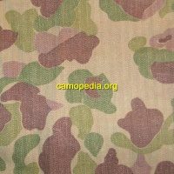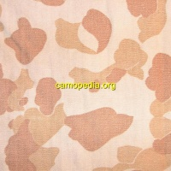
- A variant of the standard M1942 reversible spot pattern camouflage was also printed on water-repellent fabric and constructed as a poncho/shelter half. As with the jungle pattern clothing, the poncho is reversible from a green dominant to a brown dominant scheme.
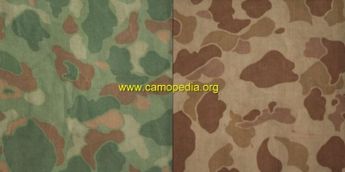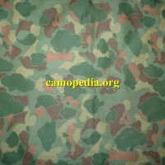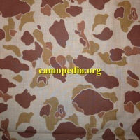
- Some WW2 era parachutes were printed with a three color green spot pattern, a pattern which continued to be used well into the 1950s. These camouflaged parachute shrouds were popular with troops during the war, often being cut into personal neck scarves or field expedient helmet covers by ground troops. Although production of camo parachutes discontinued prior to the Vietnam War, when the waterproofed poncho was introduced the first style poncho liner (design to act both as insulator for the poncho or as a makeshift blanket) was made from the same type of fabric and printed in the same pattern.
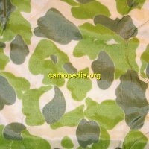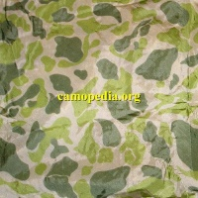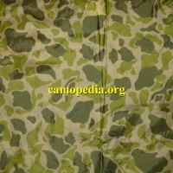
- Another interesting pattern printed on parachutes is seen here. This mottled design has been documented on US Navy Mk 17 parachutes, which were used with certain types of ordnance during the 1950s and 1960s. Presumably the pattern fell into disuse, but it is uncertain precisely when this happened.
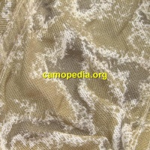
- US Army trials of 1953 produced two additional camouflage patterns that were adopted for limited use by military personnel. Both patterns saw widespread distribution only as a reversible shelter half (1953) and reversible helmet cover (1959), with one pattern printed on each side. The USMC standard or “wine leaf” (sometimes called "vine leaf") pattern, consists of large overlapping dark green, lime green & ochre leaf shapes with brown twigs on a pale green background. Some tailor made clothing in this pattern did appear during the Vietnam War, made in Japan or South Vietnam from cannibalized shelters or Asian made fabric copied form the US design.
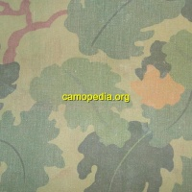
- The USMC Mitchell or “clouds” pattern, consists of overlapping dark brown, russet, beige, light brown & ochre "cloud" shapes on a tan background, was printed on the reverse side of the shelter half and helmet cover. A variation of this pattern was adopted by the Police Field Force of South Vietnam.
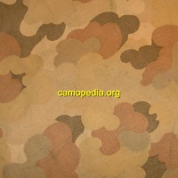
- The US Army Engineer Research and Development Laboratory (ERDL) designed a general purpose jungle camouflage consisting of mid-brown & grass green organic shapes with black "branches" on a lime green background in 1948.^{[1]} This pattern, often copied and still in usage today by other nations, is generally referred to as the ERDL camouflage pattern. Although initially shelved, the pattern was revived for testing in 1962, and several hundred ERDL tropical combat uniforms were sent to Vietnam for evaluation by USARV in 1966. The fabric was given full infared control treatment. ^{[2]}. Beginning in 1967, ERDL camouflage tropical uniforms began seeing service with reconnaissance and Special Forces personnel deployed to Vietnam. The uniforms were also highly favored by the US Marines, and were obtained in limited quantities by Australian and New Zealand special forces teams deployed there. Personal accounts from veterans and personnel from the postwar period suggest the uniforms were often referred to as "leaf" pattern and even as "flower power" jungle fatigues. The original ERDL pattern was predominantly green printed on a cotton poplin fabric; later versions were printed in a new "ripstop" poplin fabric. The green dominant design has often been labeled a "lowlands" pattern, referring to its suitability as camouflage in the lush, lowland regions of Southest Asia. Notable to the original ERDL camouflage is the fact that printing was often inconsistent, with rollers frequently experiencing slippages that resulted in overprinting of one or more colors in the pattern, leaving a shadow-like outline to many of the shapes in the design. As a result, several variations can be observed in fabric batches produced over the years.
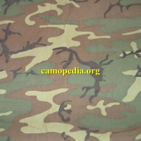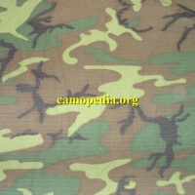
- Also released in 1968 was a predominantly brown variation of the ERDL pattern, consisting of mid-brown & grass green organic shapes (the ratio being reversed from the green dominant) with black "branches" on a khaki-tan background. This version has often been labeled a "highlands" pattern, referring to its suitability for application as camouflage in the rocky, mountainous regions of Southeast Asia. As with the green-dominant ERDL pattern, roller-slippage during the printing process frequently resulted in shadows surrounding the primary shapes. A variation of the pattern was also printed on cotton sateen fabric for an experimental camouflage version of the standard US Army OG 107 third series uniform.
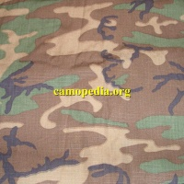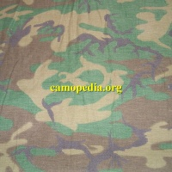
- The US Army began researching camouflage patterns suitable for deployment to desert regions in the mid-1960s, in anticipation of the need to deploy personnel to the Middle East in response to a full scale war between Israel and the surrounding Arab countries.^{[3]} One of the test patterns during the trial phase utilized the rocky deserts of California as the basis for its design. This pattern received a procurement description in 1973^{[4]}, although examples of uniforms exist that are dated 1972. The design consists of two shades of mid-brown over larger areas of sand & tan, dotted with smaller "rock" shapes in black & off white. This desert scheme was produced primarily between 1981 and 1991, and saw considerable service with US military personnel serving on desert exercises in the Sinai, and during military operations in the Persian Gulf (Desert Storm) & in Somalia (Restore Hope). Some surviving examples of the pattern illustrate slight differences in the size and percentage of black shown in the "chip" or "rock" elements, suggesting that the pattern was modified slightly at some early stage in its design. These inconsistencies generally do not appear on later production uniforms, although in fact they are also missing from a vast majority of the early production uniforms as well. A direct photo comparison of the two types can be seen [here]. The six-color desert pattern has affectionately become known as "chocolate chip" pattern, owing to the resemblance of the black elements to this well-loved cookie ingredient.
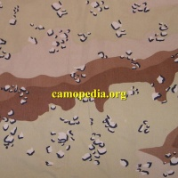
- The original slant-pocket M1967 jungle uniforms were only sanctioned for use by US military personnel deployed to Southeast Asia during the Vietnam War. Once the war ended, the original ERDL uniforms saw only scattered usage, primarily by the US Marine Corps and US airborne/special operations community. Beginning in 1979, however, the DOD again reconsidered camouflage uniforms for issue to military personnel, and designed the Hot Weather Uniform (in a slightly varied cut from the Vietnam era jungle uniform) utilizing surplus stocks of green and brown dominant ERDL camouflage. Subsequent textile production for this uniform saw a distinctive color change from the Vietnam era ERDL patterns, creating what has come to be known among some historians as "transitional ERDL" or "ERDL 2nd generation." Developers at the US Army's Natick Laboratories referred to variations of this pattern as NLABS-1 and NLABS-2.^{[5]} This pattern features mid-brown & grass green organic shapes with black "branches" on an light olive green background, although surviving samples illustrate that several color-dye variations were produced. This 2nd Generation ERDL uniform was primarily distributed to members of the Rapid Deployment Force and the USMC (along with some special operations personnel), but was officially only in production from 1979 to 1981.
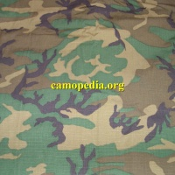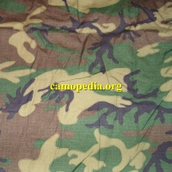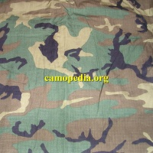
- In 1981 the US Army began full scale production of a modified version of the 2nd generation ERDL pattern known as Woodland Camouflage. Retaining essentially the same colorway of light green, dark green, brown and black, the pattern incorporates a 60% enlargement of the original ERDL design. The m81 Woodland Camouflage was initially adopted as standard combat and everyday dress by the US Army and USMC (followed by the remaining military services by the late 1980s) and was produced in a wide variety of uniform types, hats, field equipment, protective wear, and the like. Uniforms in several fabric types have been produced since its adoption, including the original 50/50 Nylon/cotton temperate weight, a 100% cotton ripstop, a fire-resistant aramid fabric, nylon for field equipment, and ultimately an enhanced ripstop fabric for BDUs which is 50% cotton and 50% nylon. The m81 woodland pattern has been one of the most duplicated and modified camouflage patterns ever designed, seeing service with military forces around the world and continuing to be worn today.
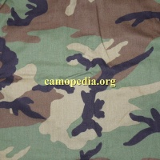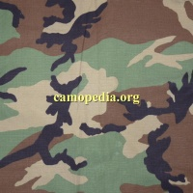
- Circa 1983, the US Army and USMC began issuing a two-piece overgarment printed in a unique grid pattern designed to defeat the Vietnam era Soviet-produced night vision equipment they were familiar with. A thigh-length parka and baggy trousers were designed to be worn over the standard combat clothing, thus providing an additional insulating layer when temperatures dropped rapidly in the desert, as well as its intended purpose as camouflage. Unfortunately, military night vision equipment of that period was considerably more sophisticated than the pattern had been designed to confuse, and production of the Night Desert pattern uniform was stopped by the mid-1990s. The camouflage scheme itself consists of a dark green "grid" design with small spots over a light olive green background. Like its counterpart, the six-color desert pattern, early production versions of this pattern differed very slightly from those of later production. The primary difference between the two variations is in the thickness of the interwoven horizontal and vertical lines. In photographs, there often occurs an optical illusion that the early variation (with thicker lines) is darker than its successor. Oddly enough, some darker dyes were used, and varied tones of green can be encountered on different examples of the pattern. A direct comparison of the two patterns side-by-side can be seen [here].
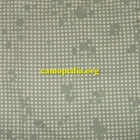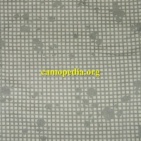
- Following the invasion of Kuwait by Iraqi Forces in 1990, the US DOD was faced with the very real necessity of outfitting a large number of combat personnel in camouflage uniforms suitable for desert warfare. Although the majority of military personnel deployed in Operations Desert Shield and Desert Storm wore either standard woodland pattern BDUs or the six-color desert pattern DBDU, the Army had already been developing a general purpose camouflage design more suitable to sparsely vegetated, sandy regions such as those found throughout Western Asia and North Africa. The resulting pattern, a three-color design, saw limited release in 1989 and was in full production by 1991, although a very small scattering of examples are known to have reached US forces during Desert Storm. Consisting of beige & earth brown horizontal waves on a sandy background, the US tricolor desert pattern (given the nickname "coffee stain" by some US personnel) was since copied & adopted by a great many nations in Western Asia and continues to serve adequately in many countries around the world. The first issue US tricolor desert pattern was printed on 50/50% NYCO twill fabric, slightly later in a 100% ripstop version, and finally (circa 1995-96) in an enhanced ripstop 50/50% NYCO fabric.
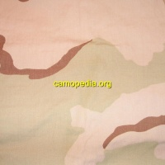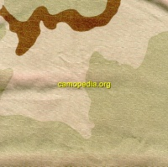
- The concept of "digital camouflage," designed using computer algorithms and incorporating pixelated shapes rather than more natural organic ones, was pioneered by the Canadian government in 1996. Impressed by statistical evidence indicating digital designs could more effectively camouflage a target than traditional organic types, and seeking a distinctive combat uniform of its own to set its Marines apart from the other US military services, the USMC sought to develop its own digital camouflage pattern. The result is the MARPAT (Marine Pattern) series of designs, adopted in 2001 (and 2005). Although the USMC has laid claim to conducting its own independent schedule of research resulting in the MARPAT camouflage, most experts in the field of camouflage design agree that in fact the they are based entirely around the original Canadian CADPAT schematic. A series of four different variations were tested, although only three were ultimately adopted by the USMC. These are: MARPAT Woodland, MARPAT Desert, MARPAT Winter, and MARPAT Urban (tested, but not adopted). One unique feature of the MARPAT series of patterns is the incorporation of a miniature USMC EGA symbol at periodic stages of the design, thus stamping the "copyright" of the US Marine Corps in these designs.
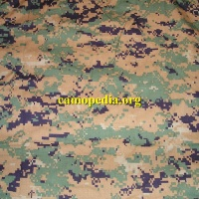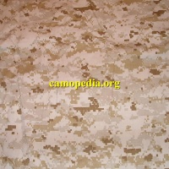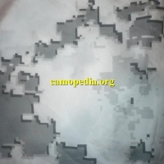
- Following on the heels of the USMC, in 2004 the US Army adopted its own "digital" camouflage pattern which it termed Universal Camouflage Pattern or UCP. This is, it turns out, nothing but a recoloration of the MARPAT design. The idea behind the concept of "universal camouflage" was to issue the soldier with a single combat uniform capable of performing suitably in any environment. This would remove the need to issue specialized camouflage clothing for soldiers deployed to different geographical areas, such as urban settings, deserts or woodland/jungles. Several years of use have shown, however, that the concept is an almost universal failure, with the UCP performing poorly (or at best only "adequately") in almost every environment, and the new Army Combat Uniform (ACU) itself standing up very inadequately as a replacement for the old BDU. The Army is currently (2010) considering new options for the combat soldier, including a higher functioning camouflage pattern and more durable combat clothing.
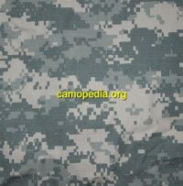
- Circa 2002 the USAF opted to join the other two branches in the pursuit of a unique camouflage design to call its own, despite the fact that the majority of USAF personnel do not operate in environments where being camouflaged makes any difference in job performance. The initial pattern tested, a blue "tiger stripe" scheme designed by American company Tiger Stripe Products, did not make the final cut, and instead the USAF chose a pixelated version of the original design. This pattern, USAF Digital Tiger Stripe, uses essentially the same colorways as the Army's UCP and at a distance looks almost the same. Still in the process of integration, it should be fully implemented into the Air Force supply system by 2011. In addition to the standard Airman's Battle Uniform (ABU) fabric, the pattern is also printed on Goretex and special flame-retardant Nomex/nylon mixed fabrics.
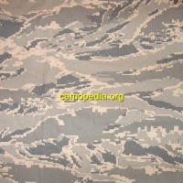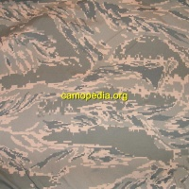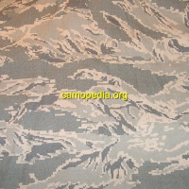
- In 2007 the US Navy introduced its own uniform, the Navy Working Uniform (NWU), using a re-coloration of the Army's UCP or Universal Camouflage Pattern. The pattern is not intented to hide the personnel wearing it, but rather to camouflage paint, oil stains, and other potential soiling, as well as to give the US Navy its own identitfiable working uniform. The pattern has subsequently come to be called NWU-1 (or NWU Type I), as the Navy adopted two additional camouflage patterns for personnel operating in combat theaters (see below). Within the Navy, this pattern has earned the nickname "blueberries."
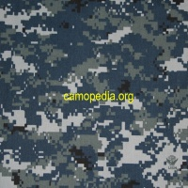
- Two additional US Navy patterns were adopted in 2010, for issue strictly to Navy Special Operations. The patterns are intended for wear in temperate/tropical and desert/arid environments, respectively, and have come to be known as NWU-3 and NWU-2 (NWU Type 3 and Type 2) respectively. Both patterns are essentially revisitations of the original USMC MARPAT design, having a vertical (vice horizontal) orientation and a slightly varied coloration. Instead of the USMC EGA logo, the NWU-2 and 3 (like the NWU-1) has the Navy coat-of-arms embedded into its design. Early trial versions of the pattern were called variously Digi 1 and 2, DG-1 and DG-2, and AOR (Area of Responsibility) 1 and 2. Although primarly intended for Navy Special Operations, the USN has indicated that NWU-3 or the temperate version of their camouflage may also be worn by Navy personnel engaged in shore-based operations, but not the NWU-2 desert variant.
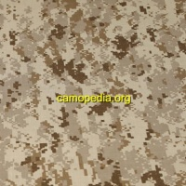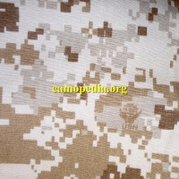
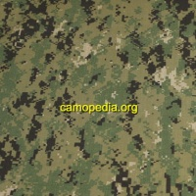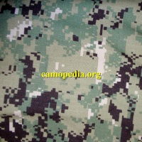
- A commonly encountered commercial pattern, and one produced by the US DOD for official issue in Afghanistan since 2010, is Multicam. Originally designed by Crye Precision and tested during the Army Combat Uniform trials of 2001-2002, it is a mottled pattern employing large regions of pinkish-tan, earth brown & light olive green with smaller regions & spots of dark brown, sand & moss green. Multicam was originally championed by personnel in the US Special Operations community, but has seen been tested and approved for issue to military personnel serving with ISAF in Afghanistan.
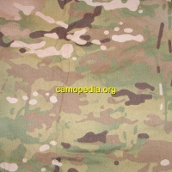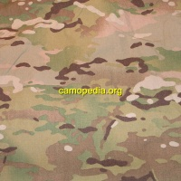
- The Department of the Army announced in 2014 that it would be retiring the short-lived Universal Camouflage Pattern (UCP) and replacing it with a different camouflage design. However, the 2014 National Defense Authorization Act (NDAA) severely restricted the choices the Army could make, disallowing adoption of any camouflage design not already in the supply system unless all four services could be convinced to adopt it. Although Multicam was considered for Army-wide adoption, licensing fees were deemed excessive and the Army instead took another look at its predecessor, the Scorpion pattern, developed in by US Army Natick Labs in conjunction with Crye Industries as part of the 2002 uniform trials that produced the Army Combat Uniform (ACU). This pattern was re-designed by Army Natick Soldier Research, Development and Engineering Center in 2009 and officially named the Scorpion W2 pattern. On official nomenclature, the pattern will be known as Operational Camouflage Pattern (OCP). Although the design does differ from Multicam, the differences are not easy to discern to the untrained eye. One difference is the colors incorporated into the pattern; both designs use seven colors, but the specific shades were changed slightly in order to avoid copyright infringement. Another major difference is absence of vertical elements that were part of the original Multicam design.
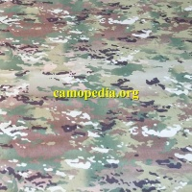

Other Camouflage Patterns Worn by US Military Personnel
- Early US Army Special Forces advisors deployed to Southeast Asia were outfitted rather inadequately for serving in the extremely warm and wet tropical climate there. Their search for more appropriate clothing, particularly to be used in conducting reconnaissance and ambush operations, led to the procurement of commercially-produced items, as no US military equivalent was available at the time. Based on the original US M1942 jungle spot camouflage pattern, lighter weight hunting uniforms made by American and Asian retail companies - frequently nicknamed "duck hunter" camouflage - were obtained privately by unit commanders and also supplied to indigenous units as part of the CIA-sponsored CIDG program. Commercial duck hunter spot pattern is generally a four or five-color dappled design of multi-sized brown, green & tan spots on khaki, tan, or pale green background. Between 1961 and 1966-7, significant numbers of these commercially available uniforms were worn by US military personnel operating in various capacities in Southeast Asia. The examples seen are but a smattering of those commonly employed.
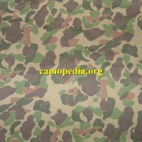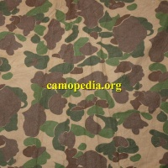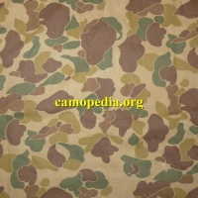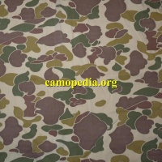
- The South Vietnamese-produced Airborne (Nhãy-Dù) camouflage was a brushstroke design based on the British 1942 windproof pattern, with broad pea green & purplish-brown brushstroke on a pinkish-tan base. This pattern was occasionally worn by US military advisors to the ARVN Airborne Division during the very early years of the Vietnam War. Some collectors and historians refer to this pattern as "ARVN pinks" due to the obvious pinkish overtones.
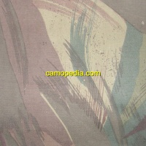
- South Vietnamese tiger stripe camouflage patterns were very popular with US military personnel during the war, both as operational clothing (employed primarily by elite units such as US Army Special Forces, Navy SEALs, and Marine Recon) and as status symbols or off-duty party garments worn by rear echelon personnel. Based on the French tenue du leopard or lizard design, a majority of the tiger patterns worn by US military personnel were made in South Vietnam. Many different styles of tiger stripe emerged between 1964 and 1975 and have been exhaustively documented by author Richard D. Johnson in his excellent book Tiger Patterns. Presented here are a handful of samples from original garments that were produced during this time period.
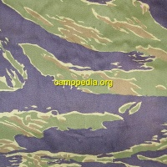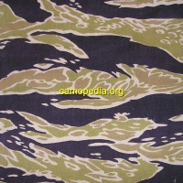Advisor's Type Dense pattern
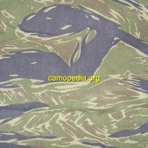Tadpole Dense pattern
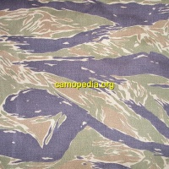Tadpole Sparse pattern
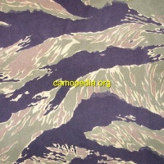John Wayne Dense pattern
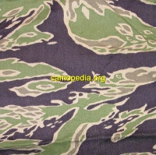Late War Lightweight Sparse pattern
- Other countries in Asia, namely Japan/Okinawa, Thailand, Hong Kong, South Korea and Taiwan, are also known to have produced tiger stripe camouflage uniforms during this period. Many of these tiger patterned uniforms, privately procured by US service personnel on R&R, did see service during the Vietnam War. The examples seen here are from wartime-era uniforms made in Thailand and South Korea/Japan
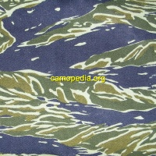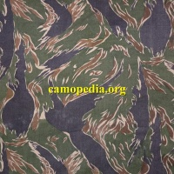
- OPFOR (Opposing Forces) units within some Infantry Divisions are often given a certain amount of flexibility in outfitting themselves with standardized uniforms not recognizable as American in appearance. This has been especially true since the end of the Cold War, with subsequent de-emphasis on traditional Soviet OPFOR models. Commercial tiger stripe patterns such as those seen here (taken from sample uniforms) are often popular in this role.
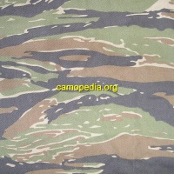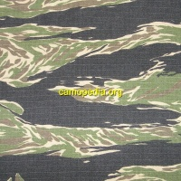
- American Special Forces personnel operating in Afghanistan (Operation Enduring Freedom) and Iraq (Operation Iraqi Freedom) have been documented as wearing commercially available Desert Tiger Stripe pattern camouflage uniforms. The pattern, originally developed by Tiger Stripe Products in the USA, features horizontal stripes of dark brown, golden brown & beige on a sandy background.
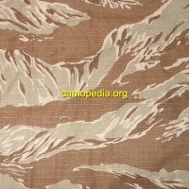

Experimental Camouflage patterns
- Several camouflage designs were tested by the US Army during the Second World War (circa 1942), none of which were ever adopted. The only pattern that we have a name for has been called the MacLaren pattern (presumably named after its developer). The design featured olive green spots printed over reddish-brown blotches with undefined edges, on a khaki or pale green background. Although full uniforms were produced, very few have survived into the present era.
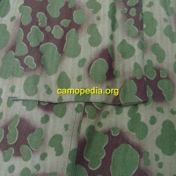
- Another US-designed pattern to come out of WW2 featured large blotches of dark brown, earth brown, beige & green on a tan background. A variation of the pattern without any green is also shown here.
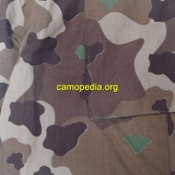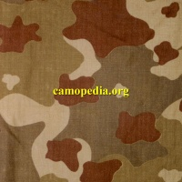
- Also tested during the 1942 trials was the pattern seen below, consisting of large russet blotches on a pink background, interspersed with small and medium-sized spots in dark green and ochre. Based on the color scheme, it is presumed this design was intended for use in desert or arid regions. Although never adopted or used operationally by American troops, surplus stocks were in fact given to the Netherlands immediately after the war, and were worn by Dutch special troops during the Indonesian War of Independence.
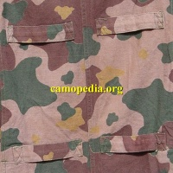
- Circa 1977 or 1978, the 2nd Armored Cavalry Regiment (US Army in Europe) tested a Dual Texture (aka Dual-Tex) camouflage pattern for Military Operations in Urban Terrain (MOUT). This design was painted on helicopters and vehicles of that unit. Following a request from the US Army Training and Doctrine Command (TRADOC), Natick Labs developed a version of the pattern for printing on fabric and test uniforms were also produced circa 1981-82. Although apparently effective, this early Dual-Tex pattern was never adopted as its appearance was reputedly unpopular with servicemen.
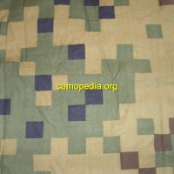
- Briefly tested in the 1980s by US Army Special Forces, this three-color (black & pale yellow on a white background) arctic/snow camouflage pattern based on the m81 woodland camouflage drawings, was never adopted. Instead the Army has continued to deploy troops operating in snowy conditions in the standard over-whites.
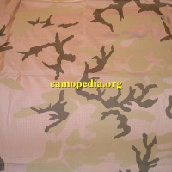
- In 1998, another MOUT pattern was tested, this time with a very dominant grey colorway. BDU shirt and trousers, as well as PASGT helmet and vest covers were produced in the pattern, termed "urban camouflage" on the nomenclature. As with its predecessor, the urban MOUT pattern (sometimes nicknamed "Urban-T" or "T-MOUT") was never adopted.
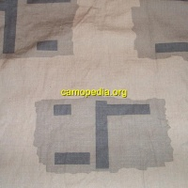
- The US Army began testing a variety of camouflage patterns in 2001-2002 to replace the m81 woodland and tricolor desert patterns. The range of designs included patterns with names such as "all-over brush," "shadow line," and "tracks," with variations of each for use in woodland, desert, urban and combination desert/urban environments. At the same time, Natick began developing a new era of combat uniform, based on improvements suggested by soldiers with field experience. This concept uniform would eventually be given the name Close Combat Uniform or CCU, and would eventually lead to the design implemented as the Army Combat Uniform. Of the new camouflage designs tested by the Army, only the "Urban Tracks" version would be fully implemented to the CCU production stage. Several hundred uniform examples were produced for testing by the Stryker Brigades in 2003-2004, although the pattern itself would be dropped in favor of the Universal Camouflage Pattern of the ACU.
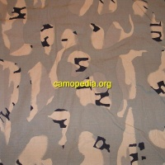
- Another experimental pattern that made it to the CCU trial stage was called "Scorpion" and was developed in conjunction with Crye Industries. This multi-environment design would later be produced commercially, with some modifications, as Multicam.
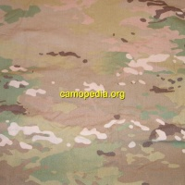
- The USAF trials of 2002 produced a blue-grey tiger stripe pattern camouflage that was rejected in favor of the grey-dominiant pixelated pattern chosen. Featuring horizontal stripes of dark blue, olive green & slate grey on a blue-grey field, the pattern was developed by Tiger Stripe Products, USA and based around the drawings used in their popular commercial patterns. A full range of uniform items were produced in the trial pattern, including enhanced BDU and Goretex gear.
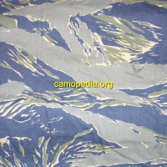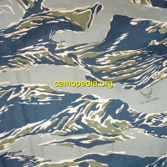
- The US Navy trials of 2003 examined several camouflage patterns for their Navy Working Uniform, including a blue-dominant and a grey-dominant digital pattern and blue dominant and grey-dominant versions of the woodland pattern.
Below is shown the grey dominant version of the woodland pattern:
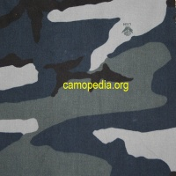
- Shown below is the grey-dominant pixelated pattern, virtually the same as that finally chosen by the USN for the NWU.
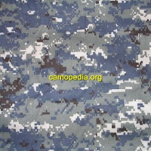
- Following several years of combat field testing in both the Iraq (OIF) and Afghanistan (OEF) theaters, the US Army and Department of Defense came to the conclusion that the UCP was not only ineffective as a "universal" camouflage pattern, but its performance was less than optimal in virtually all combat conditions being faced by soldiers. In 2008-9, as a stop-gap method, the Army issued two different camouflage patterns to selected units operating in Afghanistan. One of these, a variation of the standard UCP called UCP-Delta (UCP-D) incorporated a coyote tan color into the scheme. This pattern was tested only for approximately six months before being discarded.
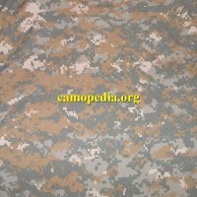
- The second version tested was the Multicam pattern printed on flame-resistant ripstop fabric. This pattern was later chosen for issue to US Army personnel operating in Afghanistan (OEF) under the name Operation-Enduring-Freedom Camouflage Pattern (OCP). As of 2012, the pattern is still being fielded to soldiers in Afghanistan, but may be replaced in the next few years with a series of officially US Army issue camouflage schemes that will replace all existing stop-gap patterns.

Comparison Photos
- A comparison of the very early and later or standard production versions of the "chocolate chip" or six-color desert pattern:
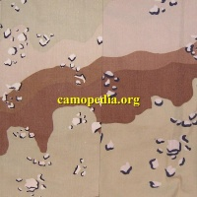
- A comparison of the early (1st) and late (2nd) pattern night desert camouflage versions:
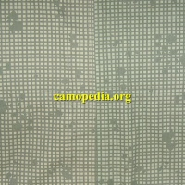

Additional Resources
- Article on the development of the CCU (Close Combat Uniform) by Eric H. Larson:
CCU

Notes

• Shelby Stanton, US Army Uniforms of the Vietnam War (Stackpole Books, Harrisburg, PA, 1989), p. 8
• • Shelby Stanton, US Army Uniforms of the Vietnam War (Stackpole Books, Harrisburg, PA, 1989), p 8-9
• • Joel B. Paskauskas, Desert Garb & Gear: the Equipment of America's Desert Warriors(Concord Publications Co, Hong Kong, 1994), p 3
• • Natick Laboratories, Combined Infantry-Army Aviation Program Review: 1971, Natick, Massachusetts, pp.4, 49
- • Alvin O. Ramsley and Walter G. Yeomans, Psychophysics of Modern Camouflage (US Army Natick Research and Development Laboratories, Massachusetts, USA, 1982), p 2

Navigation menu
- Page
- Discussion
- View source
- History
- Log in

Navigation
- Main page
- Countries A-D
- Countries E-K
- Countries L-P
- Countries Q-Z
- List of patterns
- Camouflage in movies
- Recent changes
- Random page

Search
Top of Form
Bottom of Form

Tools
- What links here
- Related changes
- Special pages
- Printable version
- Permanent link
- Page information

Links
- Comments/Contributions
- ICUS
- References
- Books
- Useful links
- Acknowledgements
- This page: www.camopedia.org
- This page was last modified on 26 May 2017,

