Ruger M-77 .7110 .308 MSRP $827 / $750 - Custom Nickel plated - tapped for scope - Excellent / as new. No box.

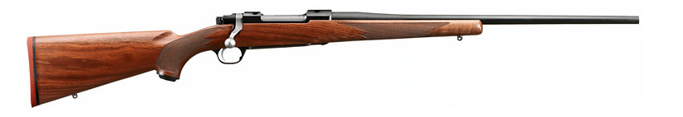

Springfield Armory M1-A .308 - National Match 20” Barrel dealer selling price - $1,575 / $1,150. Excellent / as new - With Box.

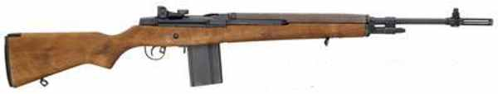

Ruger Mini-14 - Stainless Steel - .223 - MSRP $950 / $800 - This is old style Min-14. Standard Walnut stock. (This rifle is currently fixed with a special folding stock - cost would be $999 with stock ) New - With Box.

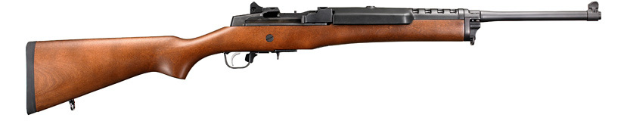
(Pictured gun has blue barrel - actual gun is Stainless.)

AR-15 - Gunsmoke Enterprises assembled .223 - $1,195 / $1,000 with blue match barrel float handguards, Bushmaster lower, flat-top no handle. 20”, collapsible stock - custom assembled by
GSE- Extremely accurate - no box - New

AR-15 - Gunsmoke Enterprises assembled .223 - $1,195 / $1,000 with blue match barrel float handguards, Bushmaster lower, flat-top no handle. 16”, collapsible stock - custom assembled by GSE- Extremely accurate - no box - New
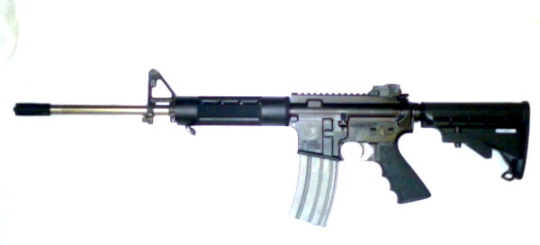

(16” SS Barrel
and Magazine pictured. Actual is blue / blue). Mag would be used GI as a throw in, as the rifles were not sold with magazines.

Marlin 1894 .44 Magnum / .44 Special - MSRP: $687.72 / $950 Barrel cut to 16 1/4 “, Nickel plated and bead blasted, classic tung oil polished stock, buckhorn sights installed, drilled and taped, swing swivels installed, with M-1 Carbine strap. (This item is currently Allocated - Number Available from distributor: 0. Basically no longer in production.) This is a one of a kind custom rifle. New with Box.

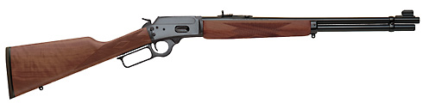

AR-7 .22LR Original Charter Arms - Henry MSRP $275 / $250. - Survival Gun
(Not exactly as pictured) Magazines, will interchange with Henry. New With Box

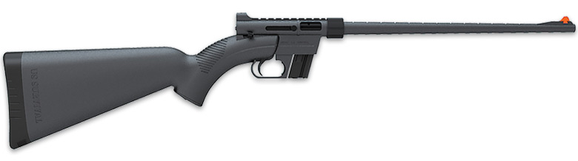

Para Ordnance P-14 -45 - MSRP: $919.00 / $750 - Steel - Double Stack , Capacity: 14+1 -
Earlier production. Solid trigger, standard hammer, less tang. three dot sights. New with Box.

